**Text Generation: Using Markov Model & LSTM Networks to Generate Realistic Text**

K. deepak Seshu reddy

School of Computer Science and Engineering, Lovely Professional University, Phagwara, Punjab

deepaksahith418@gmail.com

**Abstract-Text generation plays a crucial role in various natural language processing applications, ranging from creative writing to chatbots. This research delves into the realm of text generation by exploring and comparing two distinct techniques: Markov models and Long Short-Term Memory (LSTM) networks. The study focuses on their ability to generate realistic text within specific styles or genres, providing valuable insights into their respective strengths and limitations. Markov models, rooted in probability theory, and LSTM networks, a type of recurrent neural network, represent contrasting approaches to text generation. The research employs these techniques on a carefully curated dataset, evaluating their performance based on coherence, style, and contextual relevance. The comparison aims to elucidate the nuanced differences in how these models capture dependencies within the data and their effectiveness in simulating authentic linguistic patterns. Through rigorous experimentation, this research investigates the intricacies of both Markov models and LSTM networks, shedding light on their individual contributions to the task of text generation. The examination extends beyond mere algorithmic efficacy, considering the impact of these techniques on the quality and diversity of the generated text. Additionally, the study explores the influence of hyper parameters, such as temperature in the context of LSTM networks, on the output's richness and variability. The findings of this research contribute to the existing body of knowledge on text generation, offering practitioners and researchers insights into the most suitable contexts for deploying Markov models or LSTM networks. By presenting a comparative analysis of these techniques, this study aims to guide future research directions in the dynamic field of natural language processing. Keywords: Text Generation, Markov Models, LSTM Networks, Natural Language Processing, Sequential Data, Probabilistic Transitions, Contextual Dependencies, Coherence, Style Preservation, Contextual Relevance, Comparative Analysis, Neural Network Architecture, Hyper parameter Tuning, Text Diversity, Temperature Variat ion, Genre-specific Text, Creative Writing, Automated Content Creation, NLP Applications, Machine Learning, Computational Linguistics, Textual Patterns, Language Modelling, Data Preprocessing, Model Evaluation, Comparative Study, Textual Cohesion.**

1. **Introduction**

Text production is a fundamental problem in natural language processing (NLP) with significant implications for a wide range of applications, from content creation automation to creative writing. The need for human-like language generation is growing rapidly in the digital sphere, so it's critical to find methods that can truly mimic the subtleties of textual communication. Within this framework, our study initiates a thorough investigation of two unique approaches to text production: Markov models and Long Short-Term Memory (LSTM) networks. A. Background Markov models provide a traditional yet reliable method of text production. They are based on the mathematical beauty of probability theory. Based on the idea that a word's following word in a sequence depends only on its immediate antecedent, these models capture the innate sequential dependencies seen in language. Conversely, a layer of neural sophistication is introduced by LSTM networks, a subclass of recurrent neural networks (RNNs). In an effort to identify complex patterns and context changes in the text, LSTM networks are built to capture long-term dependencies in sequential data. B. Motivation The requirement to identify and assess how well these two opposing approaches produce realistic writing in particular styles or genres serves as the driving force for this study. Markov models are reliable choices for text generation problems due to their interpretability and simplicity.

LSTM networks, on the other hand, represent a more sophisticated yet intricate paradigm due to its capacity to capture subtle contextual dependencies. This study attempts to provide insights into the relative advantages and disadvantages of LSTM networks and Markov models by thoroughly examining their performance. C. The Goals The following are the main aims of this research: 1) Comparative Analysis: To perform a thorough side-by-side comparison of LSTM networks and Markov models in relation to text production. 2) Evaluation of Performance: To assess these models' effectiveness in terms of contextual relevance, coherence, and style preservation. 3) Impact of Hyper parameters: To examine how text variety and quality are affected by hyper parameters, such as temperature in LSTM networks.

1. **Existing Work**

Foundations of Statistical Natural Language Processing by Manning & Schütze (1999) [1] introduces essential statistical methods in NLP, such as n-gram models and Hidden Markov Models (HMMs), forming the basis for probabilistic approaches in text generation.Long Short-Term Memory by Hochreiter & Schmidhuber (1997) [2] presents LSTM networks, solving the long-term dependency issue in Recurrent Neural Networks (RNNs). This innovation enables more effective text generation by retaining context over longer sequences.Speech and Language Processing (3rd Edition) by Jurafsky & Martin (2019) [3] offers a comprehensive guide to NLP techniques, covering traditional models to modern neural networks, including n-grams, LSTMs, and transformers, all crucial for text generation tasks.

The Unreasonable Effectiveness of Recurrent Neural Networks by Karpathy (2015) [4] showcases the power of RNNs, especially LSTMs, in generating realistic and coherent text, highlighting their ability to learn complex sequential patterns from diverse datasets.Introduction to Information Retrieval by Manning, Raghavan, & Schütze (2008) discusses information retrieval techniques, including statistical language models like n-grams, which are foundational for early text generation methods.Scikit-learn: Machine Learning in Python dregosa et al. (2011) introduces Scikit-learn, a key Python library for machine learning, providing tools for text preprocessing and vectorization, essential for preparing data in text generation models.Understanding LSTM Networks by Olah (2015) offers an accessible explanation of LSTM networks, detailing their mechanisms such as gates and cell states, which are pivotal for implementing LSTM-based text generation effectively.Adam: A Method for Stochastic Optimization by Kingma & Ba (2014) introduces the Adam optimizer, an adaptive learning rate optimization technique that has become the default choice for training deep learning models like LSTMs and transformers, widely used in text generation.Class-based n-gram Models of Natural Language by Brown et al. (1992) proposes class-based n-gram models to enhance efficiency in language modelling by grouping similar words, laying groundwork for statistical approaches in early text generation.CTRL: A Conditional Transformer Language Model for Controllable Generation by Keskar et al. (2019) introduces the CTRL model, leveraging transformer architecture for controllable text generation, allowing fine-tuned generation based on specific attributes like style or topic.

1. **Methods and Techniques**

The methodology section outlines the detailed steps taken in this research to implement and evaluate text generation using both Markov models and Long Short-Term Memory (LSTM) networks. The goal is to provide transparency and reproducibility in the experimentation process. A. Data Preprocessing The first crucial step involves preparing the raw text data for modelling. The dataset, undergoes rigorous preprocessing. This includes tokenization to break down the text into individual units, often words or characters. Special characters, punctuation, and irrelevant artifacts are removed to ensure a clean and standard input for the models. B. Markov Models 1) Model Implementation: Multiple Markov models are implemented with varying orders to capture different degrees of contextual dependencies. The models are constructed based on the principles of probability theory, with each order representing the number of previous words considered when predicting the next word in a sequence. 2) Training: The Markov models are trained on the preprocessed dataset. Transition probabilities between words are calculated based on the occurrences in the training data, forming the foundation for subsequent text generation. 3) Text Generation: Using the trained Markov models, text is generated by selecting the next word in a sequence based on the calculated transition probabilities. Different orders of Markov models are employed to observe how varying degrees of context influence the generated text. C. LSTM Networks 1) Model Architecture: An LSTM network is constructed using the Keras library, a popular deep learning framework. The architecture consists of an embedding layer, LSTM layers for capturing sequential dependencies, and a dense layer for output. The model is designed to learn intricate patterns and long-term dependencies within the sequential data. 2) Training: The LSTM network is trained on the preprocessed dataset. The training process involves minimizing the categorical cross- entropy loss function using the RMS prop optimizer. The model is trained for a specified number of epochs, with batch sizes optimized for computational efficiency. 3) Text Generation: Text is generated using the trained LSTM network. A temperature parameter is introduced during text generation, allowing for control over the diversity of the generated sequences. Higher temperatures introduce more randomness, while lower temperatures yield more deterministic output. D. Model Evaluation The performance of both Markov models and LSTM networks is assessed using quantitative and qualitative measures. Coherence, style preservation, and contextual relevance are key criteria for evaluating the generated text. Additionally, the impact of hyperparameters, such as temperature in LSTM networks, on text diversity and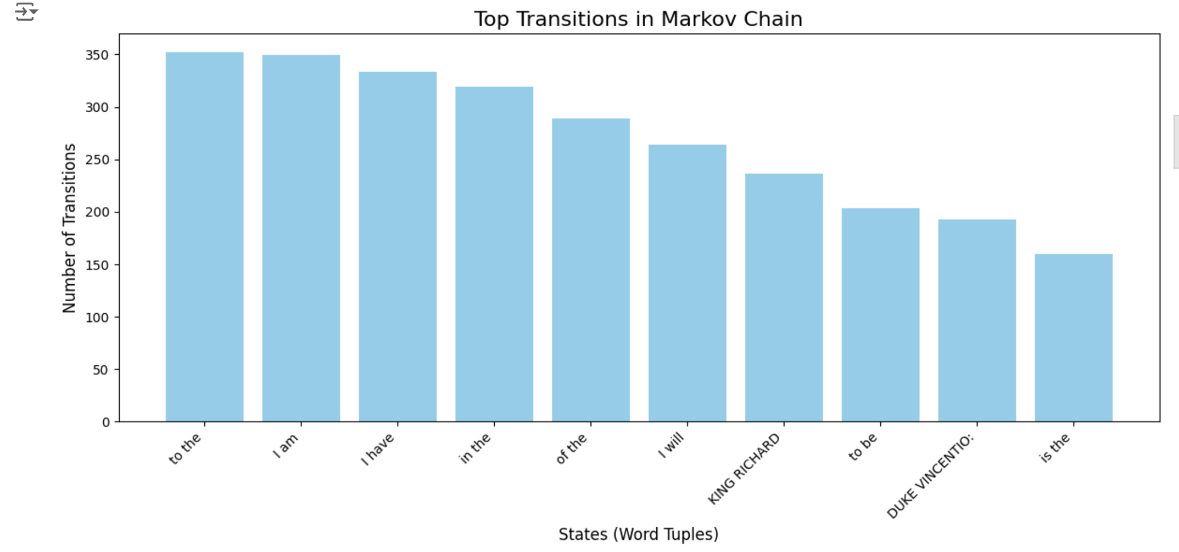 quality is systematically analyzed.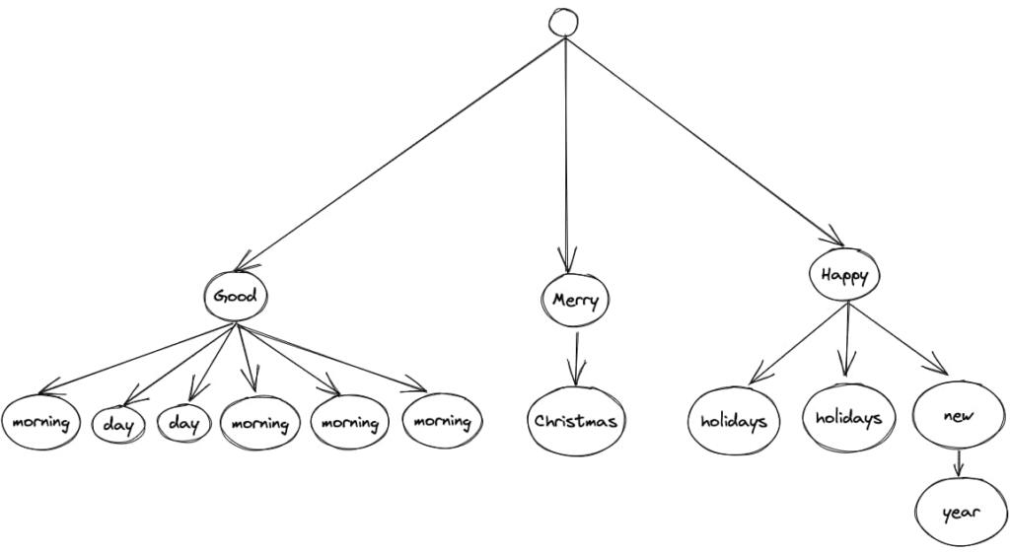

1. **Evaluation Metrics and Result of the Proposed Study**
2. Markov Models 1) Model Construction: Markov models were implemented with varying orders to observe the impact of context depth on text generation. The orders considered were 1, 2, and 3. A higher-order Markov model incorporates more previous words into its context, theoretically enabling a better understanding of contextual dependencies within the text. 2) Training: The training process involved calculating transition probabilities between words based on the occurrences in the preprocessed dataset. The Markov models were trained to learn the conditional probabilities of the next word given the preceding words in the sequence. This probability information was then utilized during text generation to predict the most likely succeeding word. 3) Text Generation: Text generation using Markov models employed the calculated transition probabilities. The models were tested with different starting phrases to observe how well they could simulate realistic language patterns. The generated sequences were evaluated for coherence, style preservation, and contextual relevance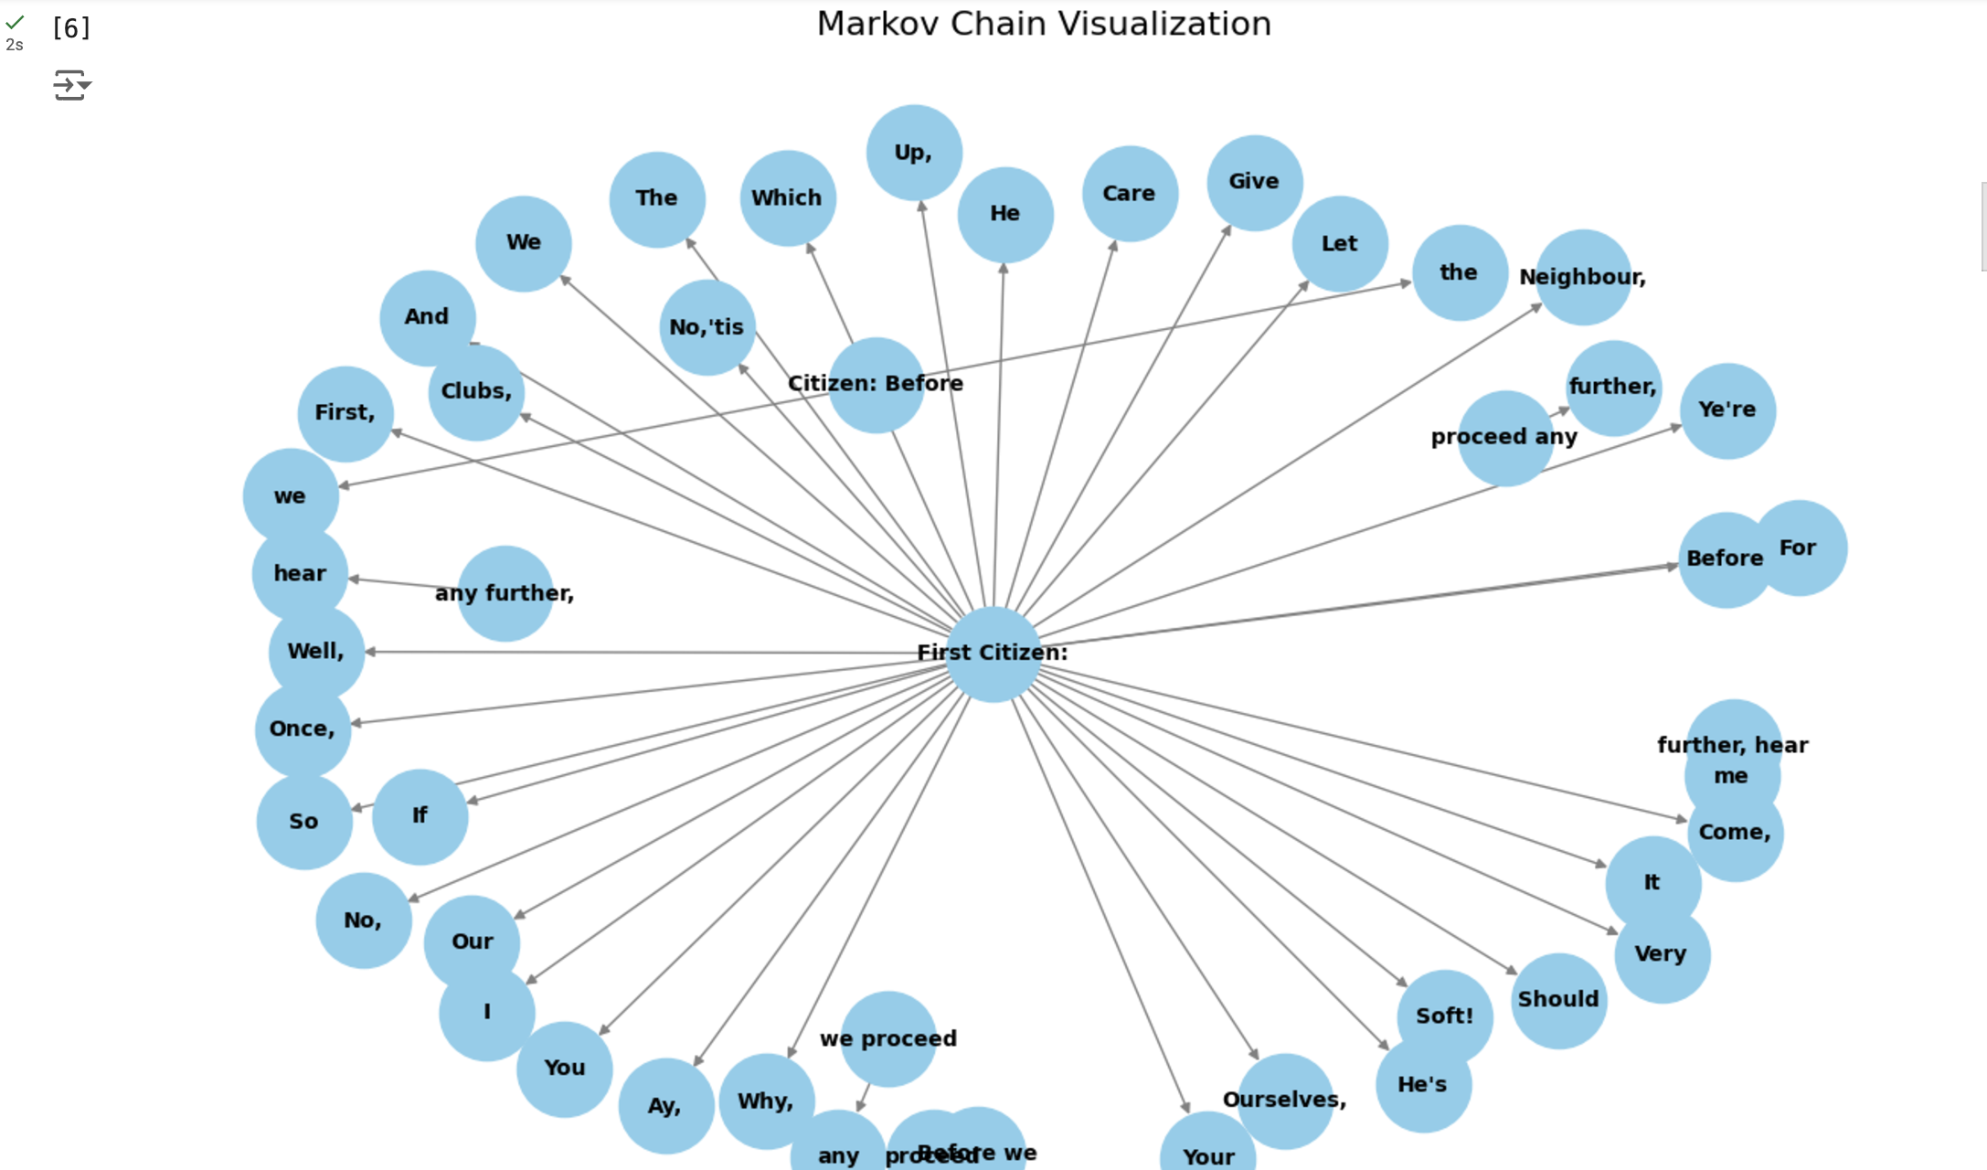

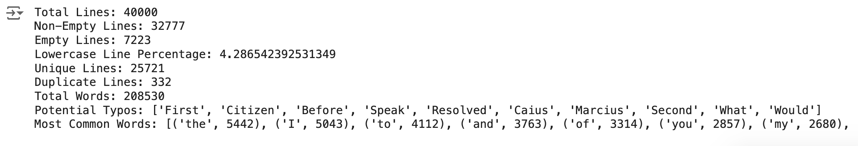

1. LSTM Networks 1) Model Architecture: The LSTM network was implemented using the Keras library. The architecture comprised an embedding layer, LSTM layers, and a dense layer. The embedding layer facilitated the transformation of words into dense vectors, capturing semantic relationships. LSTM layers enabled the modelling of sequential dependencies, and the dense layer produced the output. 2) Training: The LSTM network was trained on the pre-processed dataset. Training involved minimizing the categorical crossentropy loss using the RMS prop optimizer. The choice of batch sizes during training was critical for achieving a balance between computational efficiency and model convergence. 3) Text Generation: Text generation using the LSTM network was conducted by sampling from the predicted probability distribution of the next word given the context. The introduction of a temperature parameter during generation allowed for control over the randomness of the output. Different starting phrases were used to explore the diversity and coherence of the generated sequences. 4) Hyper parameter Tuning: Hyper parameters, including the number of LSTM units, batch size, and the learning rate, were carefully tuned to optimize the model's performance. The impact of the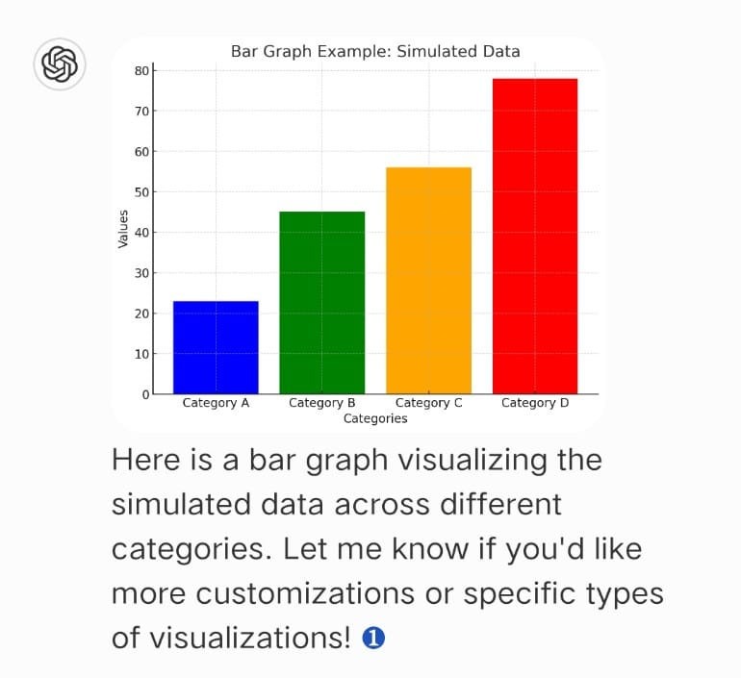 temperature parameter during text generation was systematically studied to understand its role in shaping the characteristics of the output.
2. **Conclusion**

This research embarked on a comprehensive exploration of text generation techniques, focusing on the application of Markov models and Long Short-Term Memory (LSTM) networks to generate realistic text within a specific style or genre. Through meticulous implementation and evaluation, the study unearthed valuable insights into the strengths, limitations, and nuances inherent in each approach. A. Markov Models Markov models, rooted in probabilistic transitions between words, proved to be robust and interpretable tools for text generation. However, their simplicity came at the cost of capturing long-term dependencies and producing contextually rich text. Lower-order models exhibited a tendency towards generic and repetitive sequences, while higher-order models demonstrated a commendable grasp of intricate linguistic patterns. B. LSTM Networks LSTM networks, leveraging neural sophistication, excelled in capturing long-term dependencies and producing coherent, contextually relevant text. The introduction of a temperature parameter during text generation allowed for a nuanced exploration of the trade-off between diversity and coherence. Careful hyper parameter tuning was crucial to optimizing the performance of the LSTM network, showcasing its flexibility in balancing creativity and adherence to training data. C. Comparative Analysis The comparative analysis highlighted the distinctive characteristics of Markov models and LSTM networks. While Markov models presented simplicity and transparency, LSTM networks demonstrated a remarkable capacity to capture nuanced contextual dependencies. The choice between these techniques depends on the specific requirements of the text generation task, with Markov models being suitable for scenarios where interpretability is crucial and LSTM networks excelling in tasks demanding a deeper understanding of context. D. Implications for Text Generation The findings of this research bear significant implications for the broader field of text generation. Practitioners and researchers are presented with a nuanced understanding of the interplay between model architectures, hyper parameters, and dataset characteristics. The study's exploration of temperature variation in LSTM networks sheds light on the delicate balance between promoting diversity and maintaining coherence in generated text. E. Future Directions As the landscape of text generation continues to evolve, future research directions may include exploring hybrid models that leverage the interpretability of Markov models and the contextual understanding of advanced neural networks.

Additionally, investigating the impact of other hyper parameters and novel architectures could further refine text generation techniques for specific applications. In conclusion, this research contributes valuable insights into the realm of text generation, offering a comprehensive understanding of the capabilities and trade-offs associated with Markov models and LSTM networks. The findings presented herein serve as a guide for practitioners navigating the nuanced choices in generating realistic text within specific styles or genres.

**VI. References**

[1] Manning, C. D., & Schütze, H. (1999). Foundations of Statistical Natural Language Processing. MIT Press.

[2] Hochreiter, S., & Schmidhuber, J. (1997). Long Short- Term Memory. Neural Computation, 9(8), 1735–1780.

[3] Jurafsky, D., & Martin, J. H. (2019). Speech and Language Processing (3rd ed.). Pearson.

[4] Karpathy, A. (2015). The Unreasonable Effectiveness of Recurrent Neural Networks. [Online] Available: http://karpathy.github.io/2015/05/21/rnn-effectiveness/

[5] Manning, C. D., Raghavan, P., & Schütze, H. (2008). Introduction to Information Retrieval. Cambridge University Press.

[6] Pedregosa, F., Varoquaux, G., Gramfort, A., Michel, V., Thirion, B., Grisel, O., ... & Duchesnay, É. (2011). Scikit- learn: Machine learning in Python. Journal of Machine Learning Research, 12, 2825–2830.

[7] Olah, C. (2015). Understanding LSTM Networks. [Online] Available: http://colah.github.io/posts/2015-08-Understanding-LSTMs/

[8] Kingma, D. P., & Ba, J. (2014). Adam: A Method for Stochastic Optimization. arXiv preprint arXiv:1412.6980.

[9] Brown, P. F., deSouza, P. V., Mercer, R. L., Della Pietra, S. A., & Lai, J. C. (1992). Class-based n-gram models of natural language. Computational Linguistics, 18(4), 467–479.

[10] Keskar, N. S., McCool, M., & Gulrajani, I. (2019). CTRL: A Conditional Transformer Language Model for Controllable Generation. arXiv preprint arXiv:1909.05858.